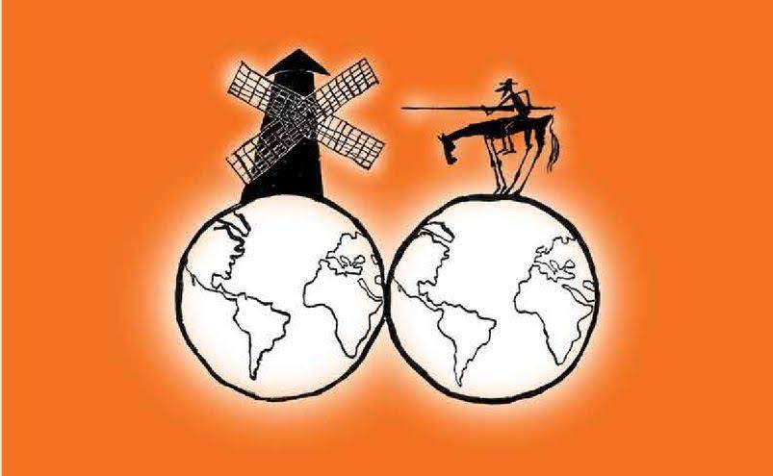
Manifesto for the Social Solidarity Economy Territory Curriculum

Four years after the birth of the Campaign for a Global Curriculum of Social Solidarity Economy, in the Year of the Pandemic, we, the signatory organizations, want to demonstrate, to claim the inaugural Letter of Principles.

The extractive model of Nature, agro-industrial productivism, unsustainable consumption patterns and the naturalization of thought based on capitalist and patriarchal logic, are largely responsible for the commercial exploitation of life, and the main culprits of the first global health, socioeconomic and climate crisis That is why, in the year of COVID-19, we consider it to be more urgent and necessary than ever, to make visible and claim the epistemologies of the territories and the wisdom of the Good Living (Bien Vivir) of the people.

This manifesto recognizes that territories host multiple ways of learning and knowing. All knowledge systems in the world are sciences. In communities there are technical, scientific, social, health, spiritual and popular knowledge that must be articulated with academics, as complementary knowledge to achieve endogenous development, from the local level.

The wisdom of indigenous peasant nations is Science with its own epistemology or theoretical framework, which implies that the way knowledge is organized, its logic, theoretical components, etc., are different. More than ever, new contributions to the epistemic diversity of the solidarity social economy of the territories, so often forgotten, are needed - contributions based on a decolonizing and intercultural education that enriches humanity and humanizes knowledge.

We claim in our Letter of Principles, in line with the recent contributions of the Manifesto for Critical and Ethical Economic and Financial Education, and the Social Solidarity Economy proposal of a Pact for the Economy for Life, proposing a Quality Education, feminist, decolonizing , which goes beyond the curricula of formal education institutions and considers the pluriversity of existing curricula.

It is the moment to generate confluence between intercultural and transdisciplinary models, with the promotion of non-violent methodologies of solidarity and epistemological fraternity among peoples. Through healthy dialogues in the territories, we overcame the orthodox and colonial matrix of the academies and arrived at a defined research not dissociated from their specific and methodological knowledge. Now all that remains is for the academy to recognize and legitimize these mixes of research and knowledge, as suns and horizons that illuminate Good Living (Bien Vivir), so that the curricula of other worlds that inhabit our territories, those of Social Solidarity Economy, can flourish.

In short, it's time to feelthinking about Southern Epistemologies.

November 26, 2020, in the Year of the Global Health Pandemic ... and Transformative Time
IV Anniversary of the Campaign for a Global Curriculum of Social Solidarity Economy

